**To Find the Reports Detailing Performance Levels by Subgroups**

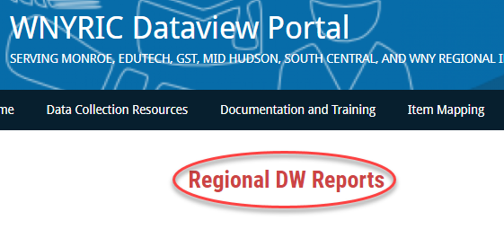

**Go to:** [**https://dataview.wnyric.org**](https://dataview.wnyric.org)

**Choose “Regional DW Reports”**

**Choose the “Team Content” folder**

**Log into Level 1**

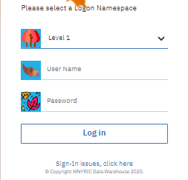 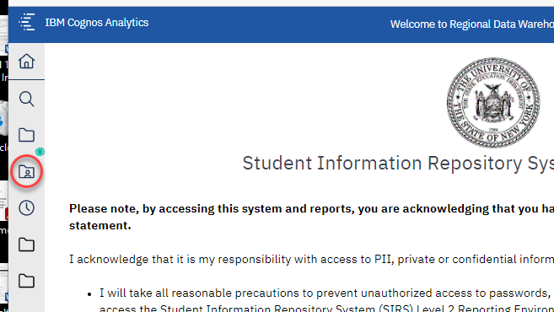

**Choose “2.0 Instructional Reports”**

**“2.1 Assessment Performance”**

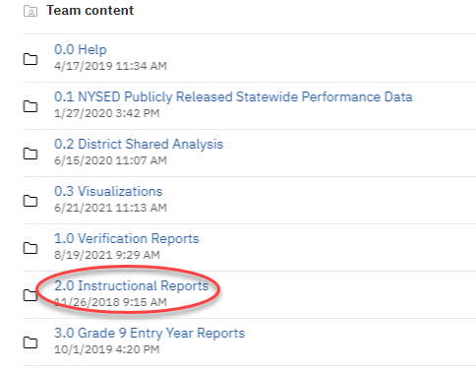 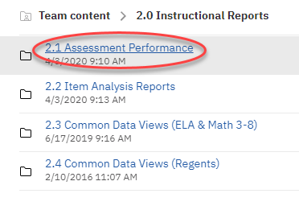

**Choose either “2.0 3-8 Performance Level Summary Reports” or “2.3 Regents Performance Level & Score Reports”**

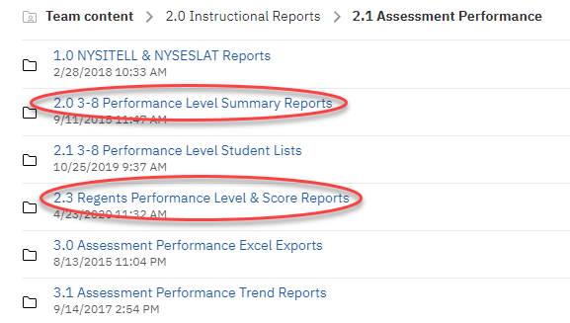

**Choose 3-8 or Regents “Performance Level Summary by Subgroup by…” District or Location**

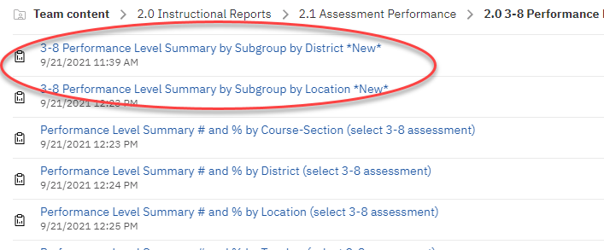 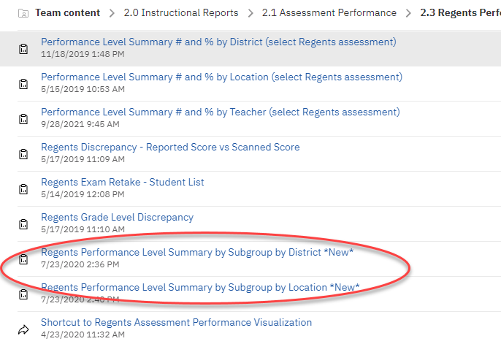

**When Customizing the report, you may wish to include multiple schoolyears, assessments and subgroups.**

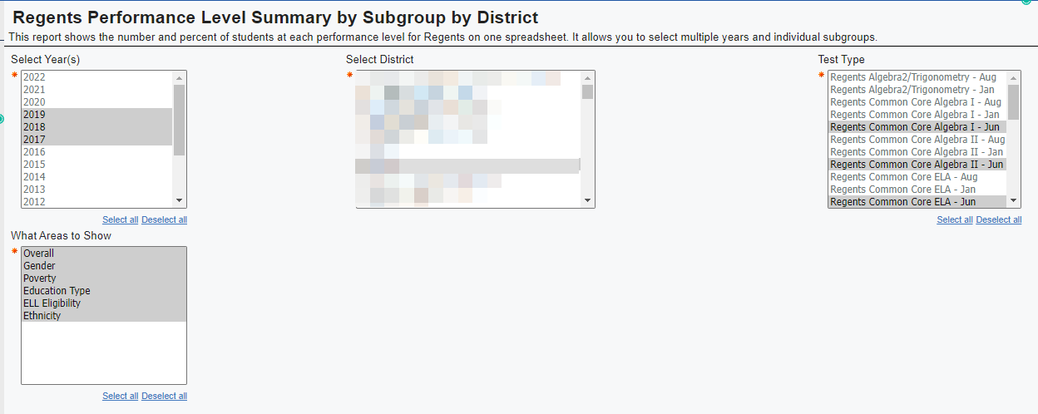

**Reports can be opened as PDFs or Excel Docs**

 